
School of Science and Engineering

CSC 5382 – AI for Digital Transformation

Milestone 2 – Development of Proof-of-Concept (PoC)

Student Name:
Ayman Ait Achour

Supervised by:
Dr. Asmaa Mourhir

Table of Contents
I. Introduction: 3
II. Model Integration 4
III. Application Development 5
IV. End-to-End Scenario Testing 6
I. Conclusion 7
V. Appendix 8
A. Source code 8
B. Interface 8

Introduction:
In Milestone 1, the problem of legacy system modernization was formally framed as a supervised machine learning task. Specifically, legacy-to-modern language migration was modeled as a code-to-code translation problem, where the objective is to generate semantically equivalent programs in a target language while preserving the underlying business logic. The business case, data sources, project archetype, baseline models, and evaluation metrics were carefully defined to establish a rigorous foundation for system development.
Following this formal problem specification, the next step is to validate the practical feasibility of the proposed approach. Therefore, the objective of Milestone 2 is to build a functional Proof-of-Concept (PoC) that demonstrates the core components of the translation system in a working environment. The PoC focuses on integrating a baseline large language model, developing a lightweight web-based interface, and validating the system through end-to-end scenario testing.
It is important to note that this milestone does not aim to deliver a fully optimized enterprise-grade solution; the primary goal is to confirm that a large language model can be successfully integrated into a web application, securely accessed via API, and used to perform cross-language code translation in a stable and reproducible manner.
The remainder of this report is structured as follows; section 2 describes the model integration process and architectural decisions; section 3 presents the development of the Streamlit-based application; section 4 demonstrates end-to-end testing and system validation.

Model Integration
The initial objective of this milestone was to integrate the open-source baseline model Magicoder-S-DS-6.7B, as identified in Milestone 1. The model was selected due to its strong code-generation capabilities and alignment with the semantic translation objectives of the project. To support local inference, a GPU-enabled HuggingFace Space was provisioned, and approximately five dollars were allocated to experiment with GPU-based deployment. Despite attempts to load the model using quantization techniques and memory optimization strategies, the system repeatedly encountered CUDA out-of-memory errors. The 7B parameter model exceeded the effective memory constraints of the available GPU environment once combined with the Streamlit runtime and supporting libraries.
Given these limitations, maintaining a stable and cost-efficient deployment environment became a priority. Rather than continuing to invest in GPU-based hosting for inference, the integration strategy was revised. The project transitioned to an API-based architecture using Google’s Gemini 3 Flash model, which offers a free usage tier and strong code-generation performance. This approach eliminated GPU dependency, reduced infrastructure complexity, and ensured stable inference through an officially supported SDK.
The integration of Gemini 3 Flash was implemented using Google’s google-genai client library. The API key was securely injected into the HuggingFace Space environment using encrypted secrets, accessed through environment variables to prevent credential exposure. The model is invoked through a structured prompt that instructs the system to translate Python code into clean, modern Java while restricting the output to Java syntax only. This ensures deterministic behavior and minimizes extraneous explanations in the generated output.
The final integration architecture follows a clean API-based design in which user input is collected via Streamlit, formatted into a translation prompt, sent to the Gemini model for inference, and returned to the interface for display. This architecture confirms the technical feasibility of large language model integration while maintaining deployment simplicity and operational stability.

Application Development
The application layer of the system was implemented using Streamlit and deployed on HuggingFace Spaces. The objective of this component is to provide a simple, interactive interface that allows users to input Python code and receive translated Java code generated by the integrated large language model.
Streamlit was selected due to its rapid prototyping capabilities, minimal configuration requirements, and seamless compatibility with Python-based machine learning workflows. Its lightweight architecture allows direct integration of model inference calls within the same execution environment as the web interface, reducing system complexity.
The application consists of three main components: the user interface layer, the prompt construction logic, and the model inference layer. The user interface collects Python code through a text input field and triggers translation upon button interaction. The input is then embedded within a structured prompt template designed to constrain the model output to valid Java code. The formatted prompt is sent to the Gemini 3 Flash Preview model via an authenticated API request. Finally, the generated Java code is returned and displayed within the interface using syntax highlighting.
The application also incorporates secure API key management through environment variables stored in HuggingFace Spaces secrets. This prevents credential exposure and aligns with secure deployment best practices. The system architecture for the application layer is illustrated below.
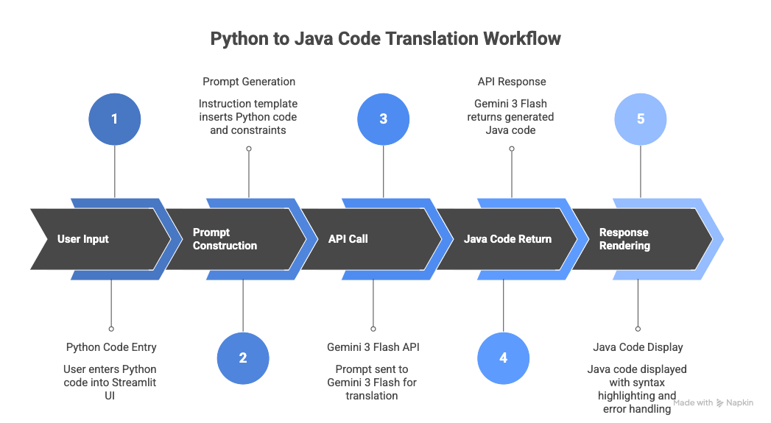
The above architecture demonstrates a clean separation between user interaction, prompt engineering, and model inference. By adopting an API-based inference model, the application avoids GPU dependency while maintaining scalability. This modular design also facilitates future extensions, including integration of pseudocode intermediate representations and retrieval-augmented generation modules.

End-to-End Scenario Testing
To ensure alignment with the datasets selected in Milestone 1, the Proof-of-Concept was evaluated using a structured example consistent with cross-language translation benchmarks such as XLCoST. The selected example corresponds to a simple conditional function that compares two integers and returns the maximum value. Although syntactically simple, this example allows validation of control flow preservation, method signature correctness, and structural equivalence between Python and Java.

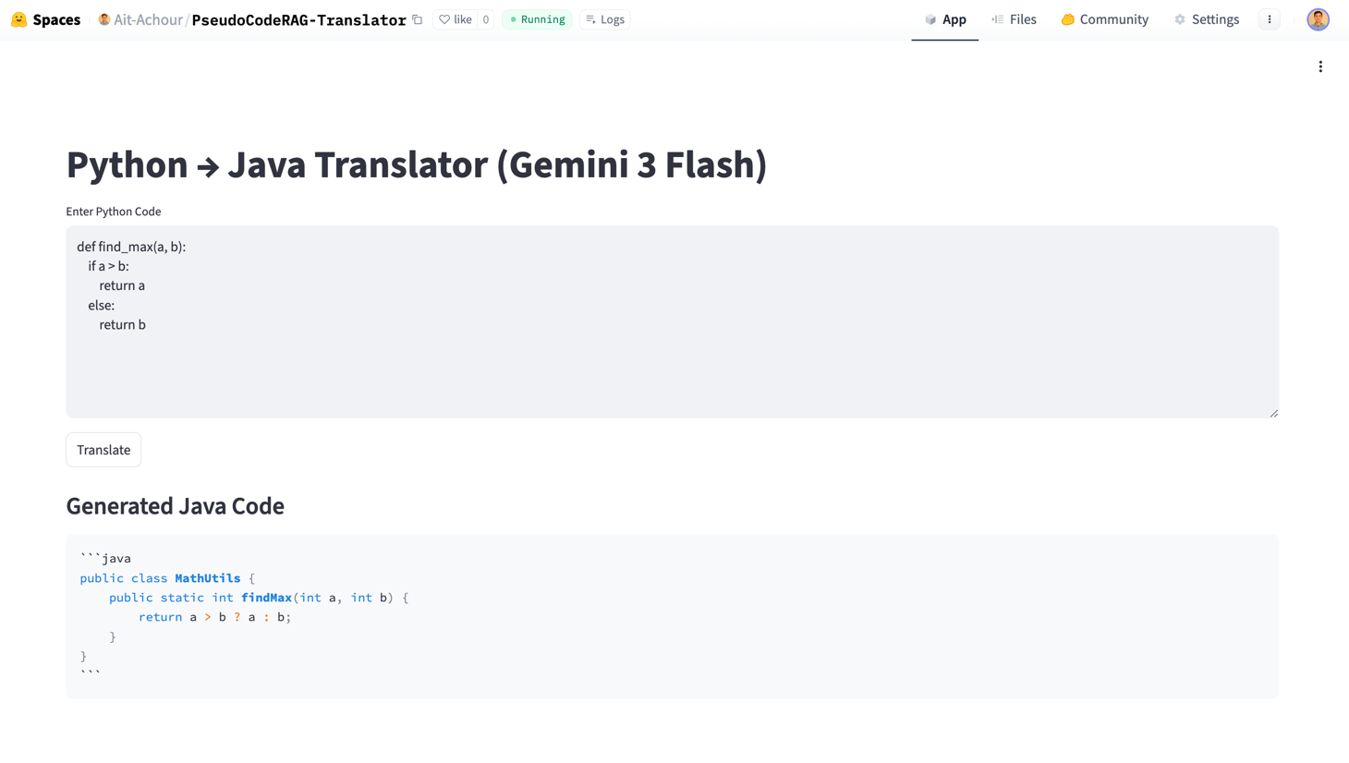
The generated output preserves the original semantic logic while correctly adapting to Java syntax. The model introduced explicit type declarations, a valid method signature, and encapsulated the function within a class structure, which is required in Java. Additionally, the if-else structure was transformed into a ternary expression, demonstrating an idiomatic and optimized Java implementation.
This example confirms that the system successfully performs end-to-end translation, from user input to model inference and output rendering. The translated code is syntactically valid and semantically equivalent to the original Python function. Although execution-based validation will be incorporated in later milestones, this experiment demonstrates that the deployed application functions correctly and produces structurally sound translations.

Conclusion
This milestone successfully delivered a functional Proof-of-Concept for Python-to-Java code translation using a large language model integrated through an API-based architecture. After framing legacy code modernization as a supervised machine learning problem in Milestone 1, this stage validated the practical feasibility of the approach by implementing a working end-to-end system. The application demonstrates stable model integration, a functional web interface, and correct semantic translation from user input to generated output.
While the current implementation focuses on validating translation capability, it represents only the first step toward a production-ready ML system. After building the PoC, the next phase of the project shifts from experimentation to structured ML pipeline development.
In Milestone 3, the focus will move toward building a robust data pipeline, including schema definition, data validation, data versioning, and preprocessing workflows. Raw data from selected datasets will be ingested, validated, and stored systematically within an MLOps framework to ensure reproducibility and reliability.
Milestone 4 will extend the system toward structured model training and offline evaluation. This includes modular project design, experiment tracking, model versioning, and integration of training workflows into the broader ML pipeline. Execution-based evaluation metrics such as pass@k and computational accuracy will be formally implemented at this stage.
Milestone 5 will transition the system into a production-ready architecture. This includes formal system design, serving modes, containerization, CI/CD integration, deployment, and scalable model serving infrastructure.
Finally, Milestone 6 will address testing beyond accuracy, including bias auditing, robustness testing, explainability, monitoring, drift detection, and continual learning pipelines. These components will ensure that the system remains reliable, transparent, and adaptable over time.
Overall, this milestone establishes a stable technical foundation upon which a complete, production-grade machine learning system for legacy code modernization will be progressively built.

Appendix

Source code
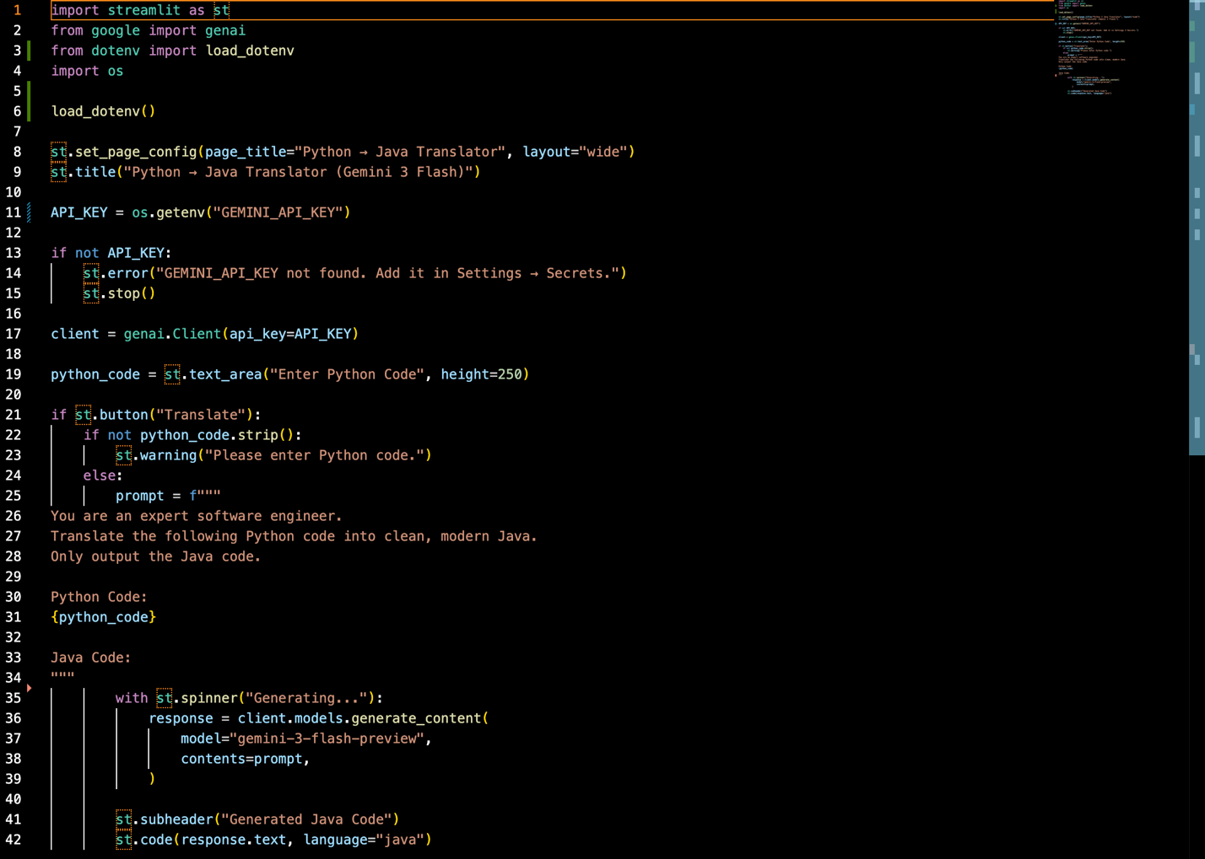

Interface
